Y2Q2W1

Joash

Ask: How old do you think a person needs to be before they can…
Go to school? Stay home alone? Walk somewhere by them selves? Sleep-over at a friend's house? Drive a car? Live by them selves? Be a king or queen?

Discuss: The ages of current and past prime ministers, kings and queens.

Say: Today we are learning about a boy who became the king.

Bible Story – DVD

Sing Songs

Return to tables
Memory Verse: Fill in the blanks and then say the memory verse on the colouring page.

Primary / Junior / Teen: This term, those of you who would like to get a Bible to take home, may take one of the orange Commandment pages and add to your book. Each week you come you can put a sticker on it and when it is all complete we will get you a Bible to take home and keep.

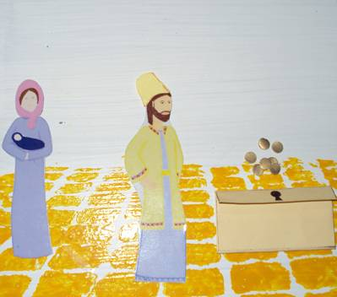
Say: This term we are going to make fridge magnets to tell the Bible stories with. You will keep your magnets in a special magnet book which we will loan to you until the end of the term and then you can take the magnets home – but we will keep the magnet books for next time. DO NOT DRAW OR WRITE ON THE MAGNET BOOKS

Magnet Books
- Hand out a nurse, baby and king.
- Fold back and tape the two flaps to make a crown.
- Fold and tape the chest and stick a magnet to the back of it.
- Take some "coins" to put in your chest. If you wish you may cut a small hole to put the coins in.

- Choose a magnet book. Write your name on a label and loop through handle.

Discuss the following depending on age, interest and time:
What things can you do to help keep our Church clean? (Don't litter or on stuff)
How can you act in Church to make it feel like a place to worship God? (Walk quietly, talk softly)
What things can you do at home to keep your home looking nice?
How can you act at home to make your home feel like a nice place to be?

Discuss: What can you do to help our Church to be a nice place?

Finish with prayer.

